1. Install two Ubuntu 18.04, one for master and one for node.
2. Install docker on both using <https://get.docker.com>

sudo apt-add-repository "deb http://apt.kubernetes.io/ kubernetes-xenial main"

apt-get update && apt-get install -y apt-transport-https curl

curl -s https://packages.cloud.google.com/apt/doc/apt-key.gpg | apt-key add -

cat <<EOF >/etc/apt/sources.list.d/kubernetes.list

deb http://apt.kubernetes.io/ kubernetes-xenial main

EOF

apt-get update

sudo apt-get -y install kubelet=1.20.2-00

sudo apt-get -y install kubeadm=1.20.2-00

sudo apt-get -y install kubectl=1.20.2-00

kubeadm init --pod-network-cidr 192.168.0.0/16 --kubernetes-version "v1.20.2"

root@ip-172-16-1-5:~# kubectl version --short

Client Version: v1.20.2

Server Version: v1.20.12

sudo apt-get -y install kubelet=1.20.12-00

sudo apt-get -y install kubectl=1.20.12-00

sudo apt-get -y install kubeadm=1.21.0-00

kubeadm upgrade apply v1.21.6

- Specified version to upgrade to "v1.21.6" is higher than the kubeadm version "v1.21.0". Upgrade kubeadm first using the tool you used to install kubeadm

sudo apt-get -y install kubeadm=1.21.6-00

kubeadm upgrade plan

kubeadm upgrade apply v1.21.6

sudo apt-get -y install kubelet=1.21.6-00

sudo apt-get -y install kubectl=1.21.6-00

sudo apt-get -y install kubeadm=1.22.3-00

kubeadm upgrade plan

kubeadm upgrade apply v1.22.3

sudo apt-get -y install kubelet=1.22.3-00

sudo apt-get -y install kubectl=1.22.3-00

mkdir -p $HOME/.kube

sudo cp -i /etc/kubernetes/admin.conf $HOME/.kube/config

sudo chown $(id -u):$(id -g) $HOME/.kube/config

kubectl apply -f <https://docs.projectcalico.org/v3.14/manifests/calico.yaml>

kubeadm upgrade plan

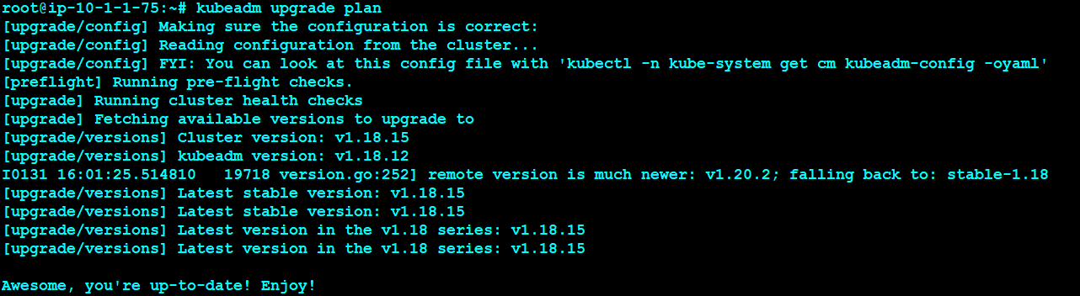

apt upgrade kubeadm=1.19.0-00

kubeadm upgrade plan

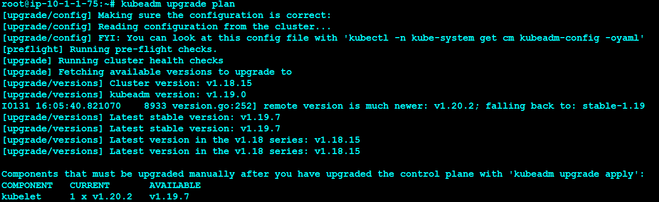

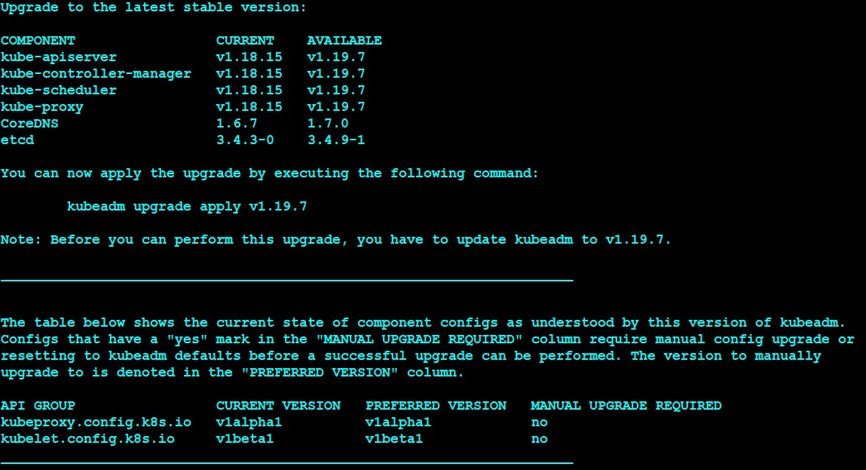

kubeadm upgrade apply v1.19.0



